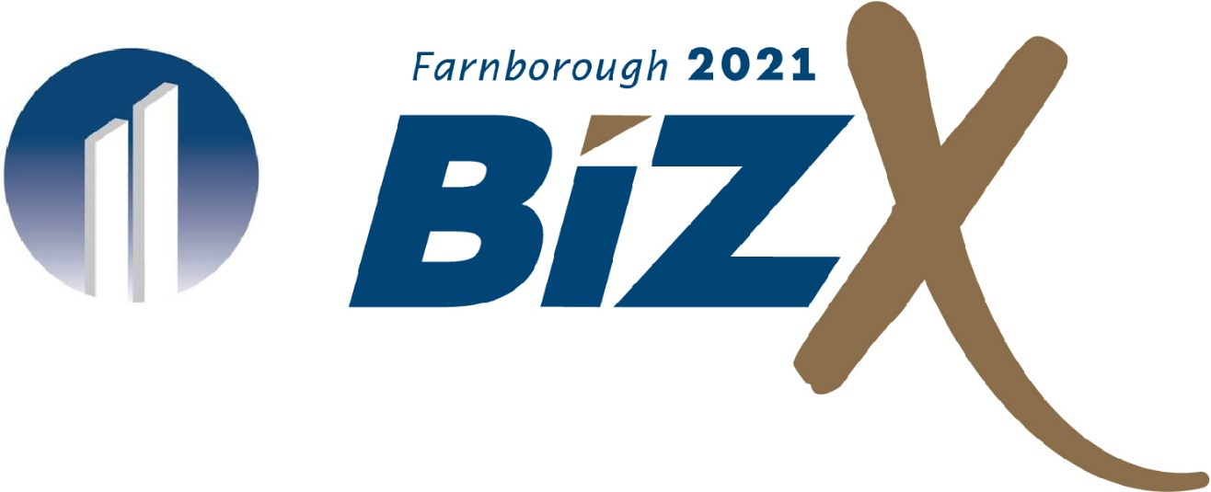
International Exhibition & Conference Centre 28th – 30th April

Fastest Growing Company

Award Entry Questionnaire
Please ensure you read the guidance on ‘what the judges are looking for’ in the Award Application Information Booklet found here: www.actioncoach.co.uk/bef-awards

IMPORTANT: A valid entry must include all of the following documentation.
- A fully completed entry form with all required information (*) completed
- Maximum 10 pages of appendices for supporting information (optional)
- A high-resolution company logo (.jpg, .eps, .pdf, .ai., .png)

About Your Organisation
*Contact Person Submitting this Entry: H
*Name of Owner/President/CEO: H
*Name of Company:
*Email: H
Website:
City:
County:
*Post Code:
*Country:
*Phone:
*Do you currently work with an ActionCOACH?
Yes ☐ No ☐

*If yes, who is your coach?

- Describe your core business and include your company mission statement. (Maximum 600 words)

- What has driven your company’s success and why? (Maximum 600 words)

- How does your business promote/advertise your product/service?
(Maximum 600 words)

- What are your business long term goals and how do you plan to achieve these? (Maximum 600 words)

- What is competitive advantage or unique selling point over your competitors? (Maximum 600 words)

- What are your milestone achievements? Include contracts you’ve won, innovations you’ve initiated, products or services you ‘ve developed or awards you have won. (Maximum 600 words)

- Please provide any notoriety public headlines/testimonials your company has received over the past 3 years. (Maximum 600 words)

- Why should your business win Fastest Growing Company? What would winning this award mean to you, your team and your business?
(Maximum 600 words)

- Please state your annual revenue for the past 2 years and how much it has grown?
 | 2019 (£) | 2019 (%) | 2020 (£) | 2020 (%)
Revenue
Profit

- Is this the first time you have attended The Business Excellence Forums & Awards?
☐ Yes
☐ No In what year(s)? H ______

- How did you hear about The Business Excellence Forums & Awards?
☐ Facebook ☐ Twitter
☐ Direct Website ☐ ActionCOACH
☐ Magazine/Newspaper ☐ Referred by a friend
☐ Other H __________

- Will you be bringing any team or family members?
☐ Yes How many? H ______ ___
☐ No

How to submit your entries
Submit this form via email to: awards@thebusinessexcellenceforums.com
OR by standard mail c/o ActionCOACH at the address below.

Disposition of Entries
Entries and materials submitted may or may not be used, displayed, shown, duplicated, published or disposed of as The Business Excellence Forums & Awards deems appropriate. We hold no responsibility to return any documents, images, or files, once submitted to us.

By submitting entries, the entrant agrees to hold The Business Excellence Forums & Awards and its employees and/or sponsors exempt from any costs or expenses of any claim arising out of any such use by us. Winners must be present at the Awards Ceremony to receive their awards.

Entry Deadline
The entry deadline is 5pm on 28th February 2021.
Entries received past the stated deadline will be ineligible.

How to Get Help
Need answers to your questions on how to prepare and/or submit your entries?

Visit our web site at: actioncoach.co.uk/bizx2021
If you can’t find the answer there, please contact us at:
The Business Excellence Forums & Awards
Broadlands Manor,
Peckleton Lane,
Leicester Forest West, LE9 9QU
Telephone: 01284 701 648
Email: freedom@actioncoach.com

